User Guide for Vaccine Changes in iTrust

Team 5

Contents

Summary 1

Modified UC1 – Vaccinator Role 1

Adding a Vaccinator (Admin) 1

Deleting a Vaccinator (Admin) 1

Modified UC6 – Vaccination Appointment Requests 1

Schedule a Vaccination Appointment (Patient) 1

View a Vaccination Appointment (Vaccinator or HCP) 1

UC17 – Vaccines 1

Add a Vaccine (Admin) 1

Edit a Vaccine (Admin) 1

Mark Vaccine Availability (Admin) 1

UC18 – Vaccination Visits 1

Document Vaccination Visit (Vaccinator/HCP) 1

View Vaccination Visit (Patient) 1

UC19 – Vaccine Certificates 1

This document will serve as a guide to the changes made to iTrust regarding the COVID-19 vaccinations. There are sections for each of the different iTrust users to understand how to utilize these changes correctly, as well as learn about the new functionality that they have.

## Summary

Functionality has now been added to cover the introduction of COVID-19 vaccinations into the healthcare system. A vaccine functionality has been incorporated into each of the different roles within the system. A vaccinator role has also been added into the system to handle vaccination appointments. It is now possible to add vaccines to the system, update the vaccines, create vaccination appointments, and track the inventory of vaccines within the system. For patients, it is possible to view their appointments, as well as download a certificate containing their vaccination information.

## Modified UC1 – Vaccinator Role

### Adding a Vaccinator (Admin)

An Admin has the ability to add a vaccinator user to the iTrust2 System. In order to do so, the Admin first must navigate to the Manage Users page:

The Admin can then user the fields within the Add a User form to add a vaccinator to the system. They will need to give them a username and password. This password needs to be more than 6 characters long, and both password fields need to match, or the system will not accept the user. They will also need to check the box giving them the ROLE_VACCINATOR, and the box that enables them. An example of a valid vaccinator is provided below:

The Admin should then click the Add User button, and the new vaccinator should now be present in the Existing Users table at the top of the page:

### Deleting a Vaccinator (Admin)

An Admin also has the ability to delete users, including vaccinators, from the system. To do so, the Admin goes back to the Manage Users tab:

From there, they can see the list of Existing Users. To the right of each user is a red Delete button. To delete a vaccinator, the Admin simply has to click that button next to the vaccinator they wish to delete:

On clicking this button, the vaccinator is removed from the system, and can no longer perform any duties.

## Modified UC6 – Vaccination Appointment Requests

### Schedule a Vaccination Appointment (Patient)

A patient has the ability to schedule a vaccination appointment to get vaccinated. To do so, they first go to the Manage Appointment Requests page:

This page shows the form to request a medical appointment, and this is where the patient will request a vaccination appointment. The patient will need to select the “vaccination” in the type field, then the vaccinator or hcp they would like to schedule with. They can then select the type of vaccine they would like, the date and the time of the appointment, as well as leave any comments they would like to. The following is an example of a valid vaccination appointment request:

On clicking “Submit Request”, the patient can now see the vaccination request is approved, and shows up in the list of their medical appointments, like this view below:

### View a Vaccination Appointment (Vaccinator or HCP)

In order to view any upcoming vaccination appointments that are assigned to a particular vaccinator or hcp, they must go to the View Appointment Requests and Upcoming Appointments:

They can then see a list of any upcoming vaccination appointments. Because vaccination requests are automatically approved, the user cannot change their values or approve them themselves. This is an example of their view:

## UC17 – Vaccines

### Add a Vaccine (Admin)

An Admin has the ability to add a vaccine to the iTrust system. To do so, they need to go to the Manage Vaccines page:

In this page, there is the Add a Vaccine form, where the admin can add a new vaccine. They need to give the vaccine a name, the number of doses (1 or 2), the minimum age for the vaccine and the maximum age, and the time between the doses if there are 2 in days. Below is an example of a valid vaccine:

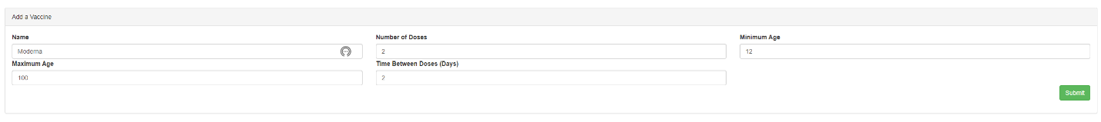

On clicking “Submit”, the newly created vaccine should appear in the Existing Vaccines table, and the availability of the vaccine should be false, as shown below:

### Edit a Vaccine (Admin)

The admin also has the ability to edit a vaccine. To do so, navigate back to the Manage Vaccines page:

To the right of each vaccine is a blue Edit button. Clicking that gives the Admin the ability to edit it:

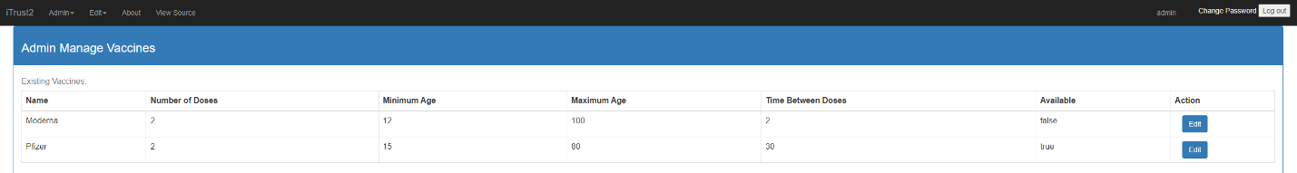

The Admin can edit any information, and then click the green “Save” button where the “Edit” button was to save their changes. The table will be updated with the changes that the Admin made.

### Mark Vaccine Availability (Admin)

In order to mark a vaccine as available to use, the Admin must go in and follow the steps for editing a vaccine. On doing so, they are going to check the box under available:

When the Admin saves this change, the vaccine becomes available and the Availability field of the vaccine changes to true. Now patients can choose to make appointments requesting this vaccine.

## UC18 – Vaccination Visits

### Document Vaccination Visit (Vaccinator/HCP)

Vaccinators and HCPs have the ability to document vaccination visits when a patient comes in to be vaccinated. To do so, they must go to the Document Vaccination Visit page:

This page has a form to document a vaccination visit. To do so, the vaccinator/hcp must put in the date and time of the visit, check whether the visit was unscheduled, and select the vaccine type, the hospital, the patient, and if the visit was prescheduled, the associated request. If the visit is the first and the vaccine requires two doses, they must also check the follow up box to schedule the next appointment. Below are examples of valid visits, one scheduled and one not:

Valid Not Scheduled Visit:

Valid Scheduled Visit:

On clicking “Submit Vaccination Visit”, the visit will be created successfully and can be viewed by the patient.

### View Vaccination Visit (Patient)

To view a vaccination visit that a vaccinator or hcp documented for a patient, the patient must go to the Past Office Visits page:

From this page, they can select a visit to view information on from the Documented Office Visits table:

On clicking “View Details”, the details of the visit pop up in a non-editable form below the table:

## UC19 – Vaccine Certificates

### Download a Vaccine Certificate (Patient)

The patient has the ability to download a certificate showing their vaccination status and vaccination visits. To do so, they must go to the Download Vaccine Certificate page:

When the patient navigates to this page, they can click to download a certificate:

On doing so, it downloads a PDF of the vaccine certificate. Below are several examples of what the certificate look like based on the vaccination status of a patient:

Fully Vaccinated, 2 Dose Vaccine:

Fully Vaccinated, 1 Dose Vaccine:

Partially Vaccinated:

Not Vaccinated:

